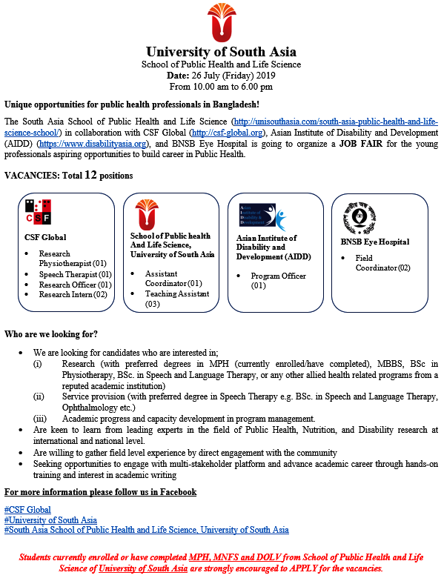
Confirm your participation through registration at the following link: https://docs.google.com/forms/d/e/1FAIpQLScvKR1pDlj5kRe0L5w_mN2MZ2rrsBkM_FuMp-B9HUOCohmWWw/viewform?vc=0&c=0&w=1

