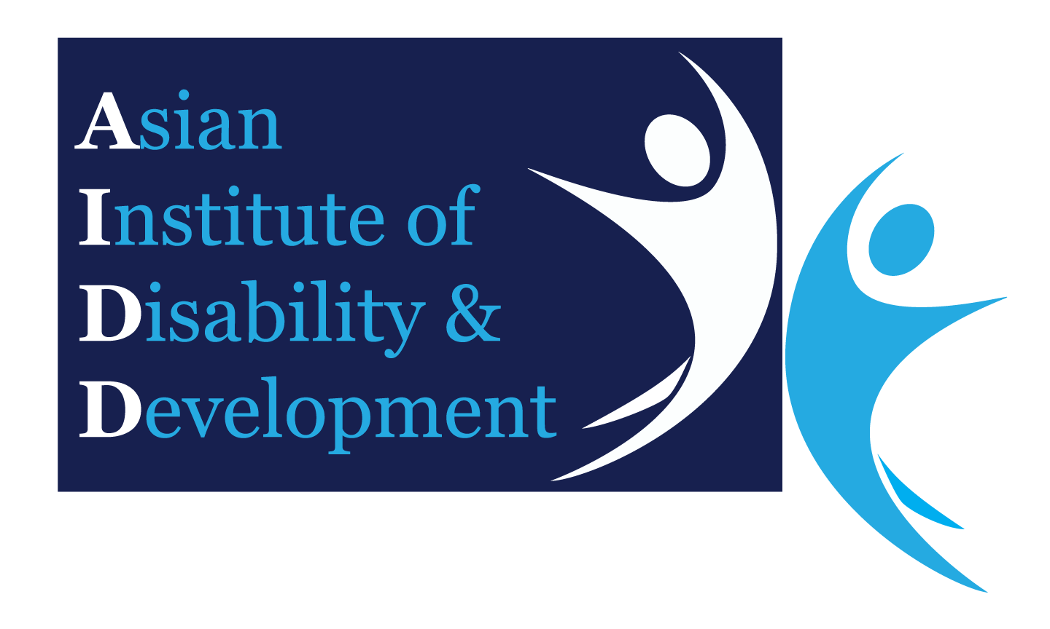
Asian Institute of Disability and Development (AIDD)
Template for Information and Consent to Participate in a Research Study

Research Study Title:
Participant Details
Surname/Last Name:
First/Given Name:
DOB: |  |  | Age: |  | Gender:
Address:

Details of Research Study:

This research study has been approved by AIDD’s (Asian Institute of Disability and Development) Research Committee and AIDD’s Ethics Committee and will be carried out in a manner conforming with the principles set out by the Bangladesh Medical Research Council (BMRC).
The aim of this Research Study is [insert short description of the aim of the research study below]

The research study will be conducted [insert a description of the methods of the research study below]

The results of this study may/may not [delete where appropriate] be of direct benefit to my current management/treatment.

It is anticipated that the results of this Research Study will [insert details of the anticipated methods of dissemination of results here - e.g. journal article, lead to further research, etc]

There are no expected adverse effects or risks related with participation in this study/the possible adverse effects or risks associated with participation in this study are (delete where appropriate) [insert a description of the possible adverse effects or risk here]

Contact and Withdrawal
Should you have an issue in regard to your participation in this study, please contact [insert details of relevant contact person here]

You can refuse to take part in this study at any time, and this withdrawal will not negatively impact on your treatment.

Privacy and Information
The information that is collected about you as a result of being part of this study will be [insert details of how this information will be stored here including security details, who will have access to the information and length of time information will be stored]

By signing this form, you consent to the collection, use and storage of your personal and health information that will be collected for the purpose of the study.
All data produced as a result of your participation in the study will be [insert details of whether the data will be de-identified or not here]
Acknowledgment
I acknowledge that:
- I am volunteering to take part in this study and I may withdraw at any time.

- I have been given information regarding the nature of and purpose of this study.

- I have read and understood the information in this Consent Form.

- I have had the opportunity to ask questions in regard to this Research Study and have been provided with answers to my satisfaction.

- I understand that the Research Study will be carried out in a manner conforming with the principles set out by the Bangladesh Medical Research Council (BMRC).

- As a speaker of English as a Second Language, the nature of the study and the implication of signing this form have been explained to me in my first language.

Signature of Participant
Printed Name: |  | Date | DD / MM / YYYY

Signature of Interpreter
[if interpreter verification is required]
Printed Name: |  | Date | DD / MM / YYYY

If the participant is unable to consent, the guardian/person responsible must sign.
If participant is between 14 and 16 years old, the participant (or guardian/person responsible) must sign as well as a parent. If under 14 years old, the parent or guardian must sign.

Signature of parent/ guardian/ person responsible
Printed Name: |  | Date | DD / MM / YYYY

Witnessed by:
Signature of Witness
Printed Name: |  | Date | DD / MM / YYYY

Project Approval No:

